7-1 Final Project Submission: System and Communication Security Paper
CYB 300 – 14668
DeLaun Robinson
August 17, 2025

- Automated Hardening Scripts: Compose a single executable script to automate hardening tasks to meet the requirements in the scenario.
  - Screenshot of a single executable script in the Linux shell environment
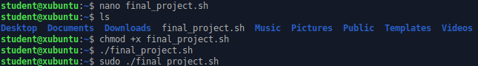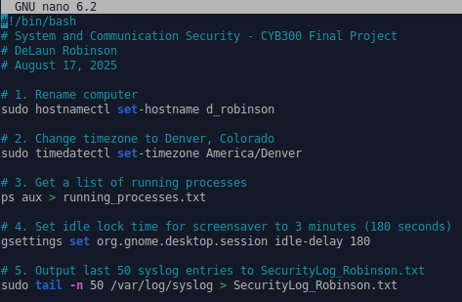
  - Screenshots that evidence each requirement has been met
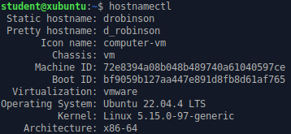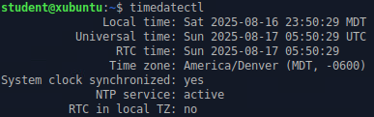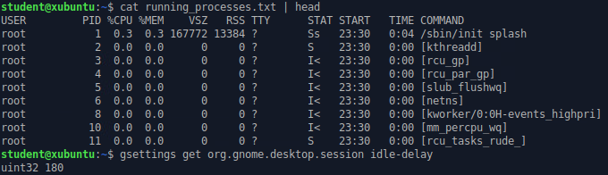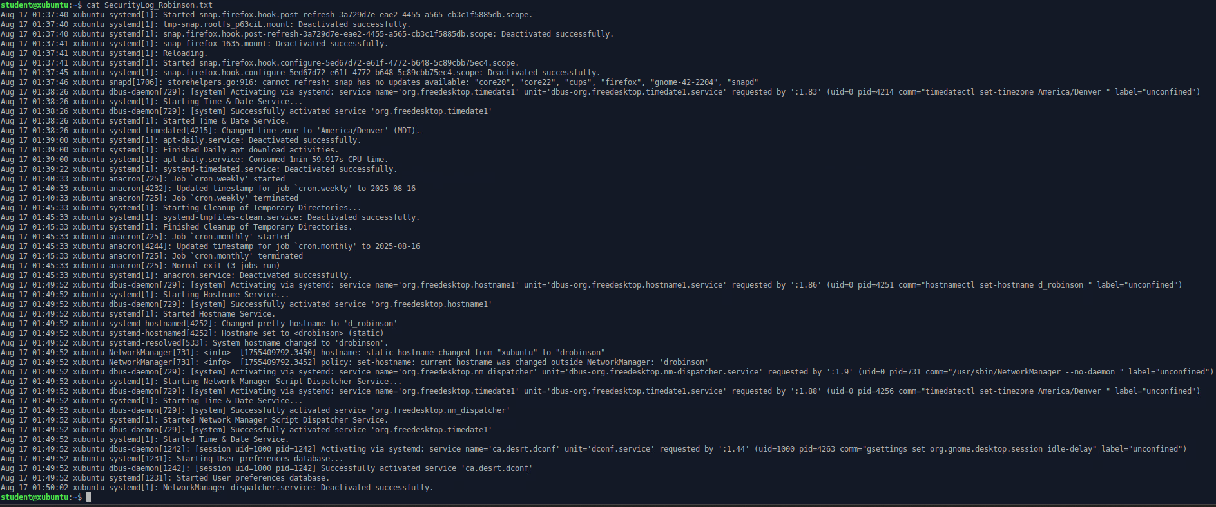
  - One of the main reasons that practitioners use automated scripts is to save time by avoiding manual configurations. Describe additional benefits of using automated scripts for configuring systems in a secure manner for organizations.
    - Besides saving time, automated scripts ensure that systems are configured consistently according to security standards, which reduces the chance of human error. They make it easier to audit and reproduce configurations across multiple machines, helping maintain compliance. Scripts also allow IT teams to quickly apply security updates and baseline settings to many systems at once, which strengthens the organization’s overall security posture.

- Certificate Authority:
  - Provide a screenshot of the OpenSSL commands to create a CA with settings that meet the organizational requirements
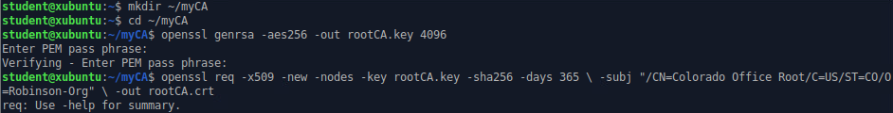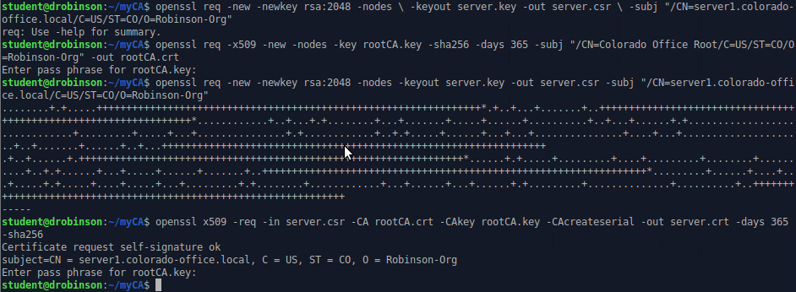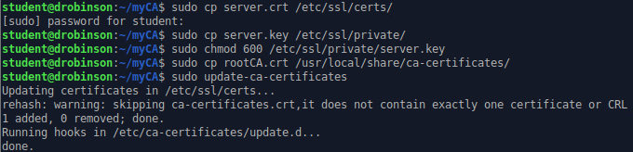
  - Discuss how to create Certificate Signing Requests (CSRs) for the servers and workstations in the new location and submit to the CA for approval (CA Applied)
    - To create a CSR for a server or workstation, the device first makes its own private key. Then it uses that key to generate a CSR with information like the system’s name and organization. The CSR is sent to the Certificate Authority (CA), which checks it and signs it. After approval, the CA gives back a signed certificate that the device can use for secure communication. This makes sure every system has a trusted certificate tied to its key and stops unauthorized devices from pretending to be trusted systems.
  - Discuss how implementing PKI addresses two of the Fundamental Security Design Principles and how this maintains the tenets of the confidentiality, integrity, and availability (CIA) triad in an organization
    - PKI helps with two important security principles. Least common mechanism is covered because all systems use the central CA instead of making their own encryption methods, which keeps security consistent. Separation of privilege is enforced because only the CA can sign certificates, so no single user or device can bypass security controls.

PKI also supports the CIA triad. Confidentiality is kept because data is encrypted with trusted certificates. Integrity is protected because signed certificates verify the data hasn’t been changed. Availability is supported because trusted certificates lower the chance of attacks that could stop services, keeping systems reliable.

- Hardening Systems
  - Discuss how to make the transition from industry guidelines to a baseline that is appropriate for your organization
    - To make the transition from general industry guidelines to a baseline that fits the organization, you first review standards like CIS Benchmarks or NIST recommendations. Then, you identify which settings are relevant for your organization’s systems, policies, and security needs. Finally, you adapt those settings into a consistent baseline that can be applied to all computers, making sure it balances security with usability. This ensures that each system is hardened in a way that meets organizational requirements while still following trusted guidelines.
  - Create an operating system security-configuration checklist representing the elements used in Part I: Automated Hardening Scripts
Rename computer to FirstInitial_LastName | Completed (d_robinson)
Set time zone to Denver, Colorado | Completed
Get list of running processes | Output saved to running_processes.txt
Set screensaver idle lock to 3 minutes | Completed
Save last 50 entries of /var/log/syslog | Output saved to SecurityLog_Robinson.txt

  - Explain why operating system security-configuration checklists are an important part of the cybersecurity practices in an organization
    - Operating system security-configuration checklists are important because they make sure all systems are configured the same way, reducing mistakes or missing settings. They also provide a clear reference for audits or troubleshooting and make it easier to train IT staff on proper security practices. Checklists help organizations maintain consistent security, apply updates efficiently, and ensure compliance with policies and industry standards

